**Experiment: 2**

PART A

(PART A: TO BE REFFERED BY STUDENTS)

**Aim:**  **To study Algorithm and Flow charts with repetition**

**Learning Outcomes: Learner would be able to**

1. Interpret the steps of algorithm into a flowchart.
2. Explain the features of each symbol of the flowchart.
3. Analysis the scenario to write algorithm and flowchart (breaking the problem into steps of selection, repetition, sequence).

**Task 1: T**he following incomplete flowchart adds all even numbers between 1 to 50. Complete it by joining X with given options

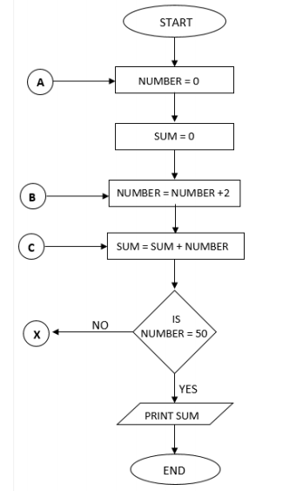

**Task2:**

Write an algorithm and draw flow chart to

1. Print numbers from 10 to 01.
2. Find *SUM = 12 + 22 + 32 +…. N2*
3. To print multiplication table for any number entered by user.
4. Write an algorithm and draw flow chart to calculate Income tax based on individual’s income.

| **Income Slab** | **Tax Rate** |
| --- | --- |
| Up to Rs.2,50,000 | No Tax |
| Rs.2,50,000 - Rs.5,00,000 | 5% |
| Rs.5,00,000 - Rs.10,00,000 | 20% |
| Rs.10,00,000 and beyond | 30% |

**Sample Test case:**

|  |  |  |
| --- | --- | --- |
| **Income from Salary** | 8,64,800 |  |
| **Income from Other Sources** | 18,400 |  |
| **Gross Total Income** |  | 8,83,200 |
| **Deductions** |  | 1,70,400 |
| **Gross Taxable Income** |  | 7,12,800 |

|  |  |  |
| --- | --- | --- |
| Up to Rs 2,50,000 | Exempt from tax | 0 |
| Rs 2,50,000 to Rs 5,00,000 | 5% (5% of Rs 5,00,000 less Rs 2,50,000) | 12,500 |
| Rs 5,00,000 to Rs 10,00,000 | 20% ( 20% of Rs 7,12,800 less Rs 5,00,000) | 42,560 |
| More than Rs Rs 10,00,000 | 30% (nil) | 0 |
| Cess | 3% of total tax (3% of Rs 12,5,00 + Rs 42,560) | 1651.8 |
| **Total Income Tax** | **Rs 12500 + Rs 42,560 + 1651.8** | **Rs 56,711.80** |

PART B

(PART B: TO BE COMPLETED BY STUDENTS)

Students must submit the soft copy as per following segments within two hours of the practical. The soft copy must be uploaded on the portal at the end of the practical. The filename should be **PPS_batch_rollno_experimentno Example: PPS_A1_A001_P2**

|  |  |
| --- | --- |
| **Roll No.:** | **Name:** |
| **Prog/Yr/Sem:** | **Batch:** |
| **Date of Experiment:** | **Date of Submission:** |

Task 1:

Task 2: Algorithm and Flowchart

**Conclusion (Learning Outcomes):** Reflect on the questions answered by you jot down your learnings about the Topic: Algorithm and Flowchart.

**Homework Questions:**

1. Write an algorithm and draw flow chart to find the sum of series 1+2+3+4+..+ up to N terms.
2. Write an algorithm and draw flow chart to find factorial of a number.
3. Write an algorithm and draw flow chart to get the lengths of three sides of a triangle. Check whether the triangle can be formed or not. If possible, then classify the triangle as equilateral, isosceles or scalene. Otherwise, if the triangle cannot be formed give the user a choice to re-enter then lengths of the sides or terminate the program.

Note: If the sum of the lengths of any two sides is greater than the length of the third side then a triangle can be formed.

Equilateral triangle: if all sides are equal.

Isosceles triangle: if any two sides are equal.

Scalene triangle: if above two condition fails.